FRD (Plain English): Cooperative Business Units and Ventures, version 3.1
Oct 11, 2026 · @Abubakar
Audience. Cooperative executives, board members, supervisory committees, unit committees, accountants and auditors. Plain English throughout, with no code.
Version 3.1.
- Non-member staff can buy on payroll credit, within their deduction capacity and with signed consent.
- Anyone can pay instantly, or pay on credit and then pay off early, in part or in full, at any time.
- Markup is charged only for the months the credit actually runs.

What changed from version 2.2
# | Change | Why
1 | Business units became a configurable framework. A society creates any unit, with its own account, committee, rules, catalogue or assets, workflows and reports | Each activity is set up, not built
2 | Two families. Member service units are demand-driven, and venture units are profit-driven | They differ in purpose, pricing, risk and how money comes back
3 | A configurable catalogue of categories, items, specifications, units of measure and portions | Units can offer any goods without new software
4 | Request rounds. Requests are pooled, the committee prices after sourcing, requesters confirm, and purchase follows full funding, then distribution and settlement | Money is raised only for confirmed demand
5 | A Watanda unit: shared purchase of an animal by equal shares or by quantity, with Eid rules, a policy for each part of the animal, a licensed abattoir and a cost-per-kilogram comparison | Digitises a common practice no app yet covers
6 | Essential commodities can be requested in any quantity, including "other items", with the price set by the committee | Members ask for what they need, and the committee finds the price
7 | Non-member staff can take part where the unit allows, paying instantly, on delivery or on payroll credit. Anyone on credit can pay off early, in part or in full | Staff share the payroll, so deductions recover their credit. It is structured as a sale on deferred payment, because the Act bars cash lending to non-members
8 | Venture units follow a lifecycle from proposal to exit, with appraisal, a liquidity test, tranches, a watch list and exit rules | Ventures caused most cooperative collapses
9 | Venture types: transport, shops, filling stations, estates and others | Covers the common outside businesses
10 | An asset register, with depreciation, insurance, permits, maintenance, hire purchase and disposal | Every durable asset is tracked
11 | Ledger additions for rounds, advances, prepayments, hire purchase and estate deposits | Every naira in a round or venture is traceable
12 | Three new separation rules and new alerts | They cover pricing, committee self-dealing and venture collections
Everything else in version 2.2 carries over:
- inventory as a separate entity;
- purchasing, cash handling and two-track reconciliation;
- the platform-built ledger;
- the optional integrations hub.

Summary
The cardinal rule still holds. A cooperative's businesses must never use, risk or mix with members' withdrawable savings. Every unit has its own account and books. Money moves between the society and a unit only by approved, two-signature payments, and every naira is traced from first payout to final return.
What version 3.0 lets a society do.
- Run member services. Open a Watanda unit for festival meat, a foodstuff unit, or an asset unit. Members, and staff where allowed, see what is on offer and request what they need. The committee buys exactly what was confirmed and paid for, prices it openly, and shares it out against delivery codes.
- Run ventures. Invest in transport, a shop, a filling station or an estate. Each goes through a gated lifecycle: plan, appraisal, members' approval, staged funding, assets in a register, daily records and monthly targets. Profit and capital come back to the society, with a watch list that stops funding when a venture goes wrong.
- Show members the facts. Members see every unit's and every venture's results.

1. The business unit framework
What a business unit is. A container the society creates and configures for one activity. Every unit has the same seven parts:
- A name and a type. For example "Watanda", "Foodstuff" or "Transport fleet".
- Its own account. A society-titled bank account or purpose wallet.
- A committee with named roles.
- Rules and settings: who may take part, approval limits, schedules, pricing and payment methods.
- A catalogue or an asset register. Member service units have a catalogue of categories, items and specifications. Venture units have an asset register.
- Workflows. Request rounds for member service units, and a venture lifecycle for venture units.
- Its own books and reports, inside the society's ledger.
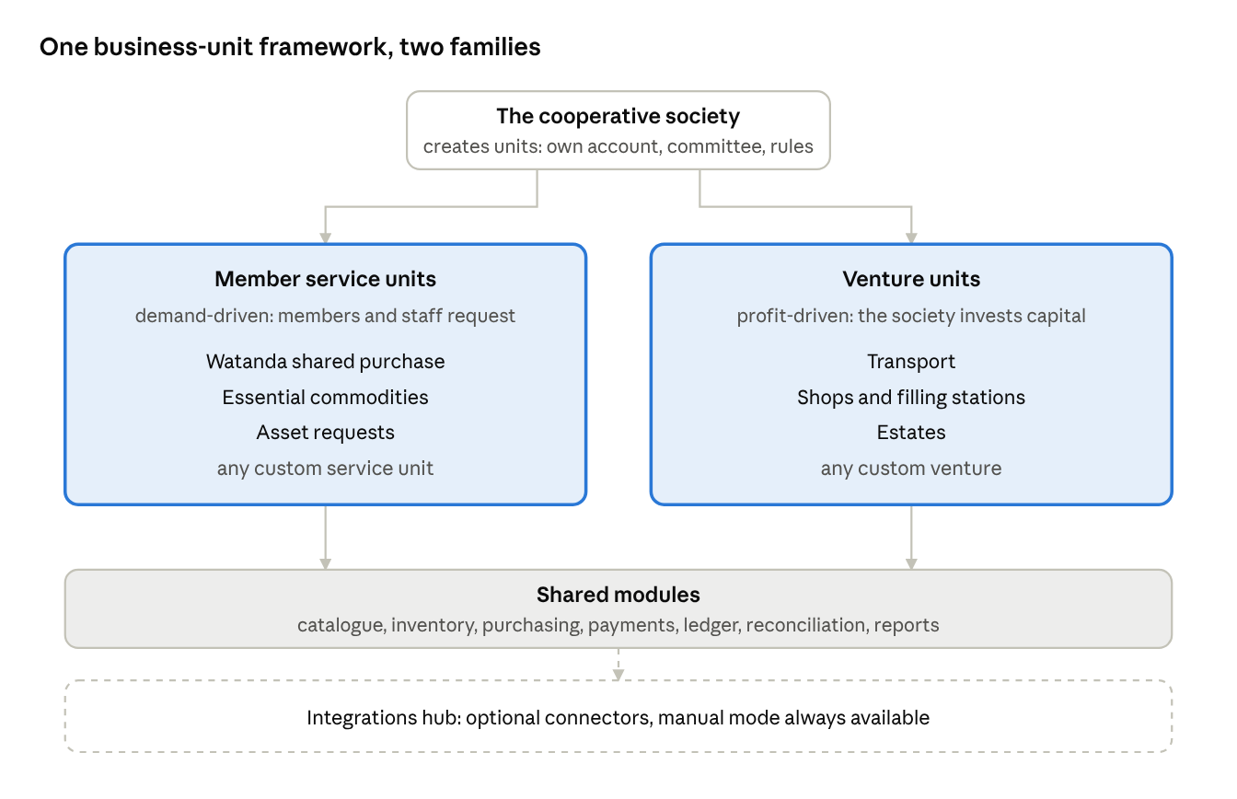
business-unit framework · two families on shared modules
Two families.
 | Member service units | Venture units
Purpose | Serve members, and optionally the organisation's staff, by buying what they ask for together | Earn profit for the society by investing its capital in an outside business
What drives spending | Members' requests. Money is raised for what was asked for, and no more | An approved business plan and capital ceiling
Who sets the price | The unit committee, after sourcing | The market. The venture sells to the public or to customers
Typical types | Watanda shared purchase, essential commodities, asset requests | Transport, shops, filling stations, estates, equipment
How money comes back | Members pay upfront or through payroll. Any small margin or fee is surplus | Operating income, then profit and capital returned to the society
Main risk | Collecting less than was spent, or goods not matching requests | Losing capital in a venture that does not earn
One framework, any activity. A society can create as many units as it needs, in either family. Each unit is visible to members, who can see what it offers and its results. Only the people the unit's rules allow can make requests. A new activity needs a new unit configuration, not new software.

2. Who does what
Society level.
Role | Duties
General meeting | Approves each venture unit and its capital ceiling, any society advance to a member service unit above the board's limit, and year-end sharing
Board | Creates units, appoints unit committees, approves unit settings and business plans, and reviews monthly results
Treasurer | Prepares payments from society accounts, and reconciles them
Signatories (two of three) | Approve every payment from society or unit accounts
Supervisory committee | Surprise counts, price checks, round and venture reviews, and the emergency freeze
Members | View every open unit, make requests where allowed, confirm prices and receive goods
Non-member staff | Where a unit's rules allow, make requests and pay instantly, on delivery or on payroll credit, and pay off early at any time
Employer payroll officer | Applies and remits payroll deductions
External auditor | Audits the society and every unit, read-only
Unit level. Each unit gets a committee. The roles it needs depend on its type.
Role | Member service units | Venture units
Unit chair | Leads the committee and signs off each round | Leads the venture committee and reports to the board
Procurement officer | Collects quotes, proposes prices and raises purchase orders | Buys assets and supplies
Storekeeper or receiving officer | Counts and inspects goods received | Receives goods for shops and depots
Distribution officer | Hands goods to requesters and collects delivery codes | Not usually needed
Venture manager | Not used | Runs daily operations of the venture
Cashier or collections officer | Takes upfront payments where cash is allowed | Records takings and driver or tenant collections
Unit secretary | Keeps minutes, publishes prices and allocations | Keeps minutes and venture reports
Separation rules. The system refuses any action that breaks a rule. Rules 1 to 9 carry over from version 2.2.
- Nobody both sells and receives stock at the same outlet.
- Whoever raises a purchase cannot approve or pay it. Whoever starts a payment cannot approve it.
- A second person always recounts a till.
- Cash handlers never reconcile the bank.
- No committee member approves a purchase from a related party.
- Whoever changes a supplier's bank details cannot approve that supplier's first payment.
- Nobody counts stock they received or issued that day without a supervisory committee co-signer.
- The distribution officer is never the person who picked or packed the goods.
- The maker of a reconciliation match never approves it.
- New. The person who proposes a round's price cannot approve that price, and cannot be its supplier or related to the supplier.
- New. A committee member's own request is approved by another committee member.
- New. A venture manager cannot approve the venture's own payouts or expenses, and drivers and tenants pay into the unit's account, never to the manager.

3. Module map and connectivity
Each module is a separate entity that owns its own records. Modules talk only through defined hand-offs. Units are configurations that use these modules, not separate software.
Module | Owns | Used by
Business units | Unit set-up, committees, rules and settings, status | Everything below
Catalogue | Categories, items, specifications, units of measure, portions | Member service units, and shop ventures
Requests and rounds | Requests, rounds, demand totals, prices offered, confirmations, allocations, settlements | Member service units
Ventures | Business plans, appraisals, funding tranches, operations logs, performance | Venture units
Asset register | Vehicles, equipment and property, with depreciation, insurance and maintenance | Venture units, and asset requests until paid
Inventory | Stock quantities, movements, counts, valuation | Rounds that hold stock, shops, essential commodities
Purchasing | Suppliers, quotes, purchase orders, goods received, invoices | Every unit
Payments | Payment requests, two-signature approvals, instructions | Every unit
Member credit and payroll check-off | Credit headroom, instalment plans, deduction schedules, remittance matching | Requests paid on payroll credit
Ledger | Books, accounts, journals, holds, balances | Every module posts here
Reconciliation and reporting | Statement matching, proofs, unit and society reports | Every unit
Integrations hub (optional) | Connectors and their manual alternatives | Payments, collections, statements, payroll, identity checks, SMS
The main hand-offs.
From | To | What passes
Business units | Requests and rounds, ventures | The unit's rules, which every request and venture step is checked against
Catalogue | Requests and rounds | The items and specifications a requester can choose
Requests and rounds | Purchasing | The round's total demand, for quotes and the purchase order
Purchasing | Requests and rounds | The sourced price and quantity available
Requests and rounds | Member credit | Credit requests, to check headroom and create instalments
Requests and rounds | Payments | Funding requests, refunds and supplier payments
Purchasing | Inventory | Goods received, where goods are stored before distribution
Inventory | Requests and rounds | Goods picked and delivered, with delivery codes
Ventures | Asset register | Assets bought, with cost and documents
Ventures | Payments | Tranche payouts, asset purchases, expenses, returns to the society
Every module | Ledger | One balanced journal per business event, or a hold
Integrations hub | Payments, reconciliation, collections, payroll | Bank confirmations, statements and remittances, only where a connector is on

4. Creating and configuring a business unit
Who creates a unit. The board, using a set-up wizard. A venture unit also needs a general meeting resolution. The unit stays in Draft until the board approves its settings. It then goes to Active, and can later be Paused or Closed.
The set-up wizard.
- Identity. Name, family, type, description and picture.
- Who can view and who can request. All members can always view an active unit. The requester groups are:
  - members only;
  - members and non-member staff of the sponsoring organisation;
  - a named list.
- Account. Link a society-titled account or purpose wallet. Venture units must have their own account. Member service units may share one service account, with the ledger separating them.
- Committee. Name the members and roles, the quorum, and who approves what.
- Funding model. One of four:
  - requesters pay before purchase;
  - the society advances money within a ceiling and recovers it from requesters;
  - payroll credit for members;
  - for ventures, capital tranches.
- Catalogue or assets. Member service units pick or build categories, items and specifications. Venture units set up their asset types.
- Pricing. Choose one:
  - set by the committee after sourcing each round;
  - a fixed price list;
  - cost plus a set margin.
Add any service fee.
- Payment modes. Choose which apply: upfront transfer, card, savings debit with the member's consent, payroll credit (members, and non-member staff where the unit allows it), or cash at a collection point.
- Schedule. Choose one:
  - always open;
  - recurring rounds, such as every month or before each festival;
  - one-off rounds.
- Rules and limits. Set them using the table below.
- Review and approve. The board approves. The settings are recorded, and every later change is logged and shown to the supervisory committee.
Unit settings. Each setting has a default and can be changed by the board.
Setting | What it controls | Example default
Requester groups | Who may request | Members only
Minimum membership | Months before a member may request | 3 months for commodities, 6 for credit
Requests per person per round | Stops one person taking a whole round | 1 request, with several items
Minimum and maximum quantity per item | Per request | Item-level
Minimum subscription | Requests needed before a round can go ahead | Watanda: all portions of one animal
Round opening and closing | When requests are accepted | Opens on the 1st, closes on the 10th
Price confirmation window | Time for requesters to accept the committee's price | 48 hours
Price change limit | How far the final price may move before requesters must re-confirm | 5% above the indicative price
Allocation rule | What happens when supply is short | Pro rata to confirmed quantities
Variance rule | How differences between what was paid and what was received are settled | Refund or charge each requester, rounded to the kobo
Service fee or margin | Added to cost | 0% to 5%
Society advance ceiling | The most the society may advance to the unit | Board-set
Approval limits | Manager, committee and board thresholds | As in version 2.2
Delivery options | Collection point, office or home | Collection point
Payment deadline | When upfront payment must be in before purchase | 24 hours before purchase
Credit terms | Tenors and markup for payroll credit | 1 to 6 months, 5% flat
Settings added in version 3.1.
Setting | What it controls | Example default
Staff credit | Whether non-member staff may buy on payroll credit | Off until the board and counsel approve
Staff credit ceiling | The most one staff member may owe the unit | Board-set, and never above their deduction capacity
Staff guarantor threshold | The amount above which staff credit needs a member guarantor | ₦250,000
Early repayment fee | Any fee for paying off a plan early | None
Over-deduction handling | What happens to payroll deductions after a plan is paid off | The requester chooses: refund or apply

5. The configurable catalogue
Categories. A category tree, for example Food, then Grains, then Rice. A unit chooses which categories it offers.
Items. Each item has these fields:
Field | Example
Name and description | Long-grain parboiled rice
Picture
Unit of measure | Bag
Conversions | 1 bag = 50 kg. Half bag allowed
Specifications | Brand, grade, size, colour, cut
Indicative price | ₦82,000 per bag, shown as a guide only
Quantity limits | Minimum 1, maximum 2 per request
Allowed units | Foodstuff, Watanda and so on
Specifications. Each specification has a name and a list of allowed values, for example cut: boneless, with bone, mixed. A requester picks one value for each specification. A combination such as "Rice, Brand A, 50 kg" is a variant, with its own indicative price and stock line.
Portions. For shared purchases, an item can be divided into portions.
- Example. One cow is divided into a number of equal shares, or into kilograms of meat.
- What each portion shows. Its expected weight and what it includes.
- Fixed by the committee. The number of portions is set before the round opens.
"Other item" requests. A unit can allow requesters to ask for something not in the catalogue. They describe it with free text and a quantity. The committee accepts it into the round, maps it to a new catalogue item, or rejects it with a reason.
Price is never final at request. In committee-priced units, the price shown at request is only indicative. The binding price is the one the committee sets after sourcing and the requester confirms.

6. Member service units: the request round
Every member service unit works in rounds. A round is one cycle of collecting requests, buying and distributing. An always-open unit groups its requests into rounds at each cut-off date. A round never spends money on anything requesters did not ask for and confirm.
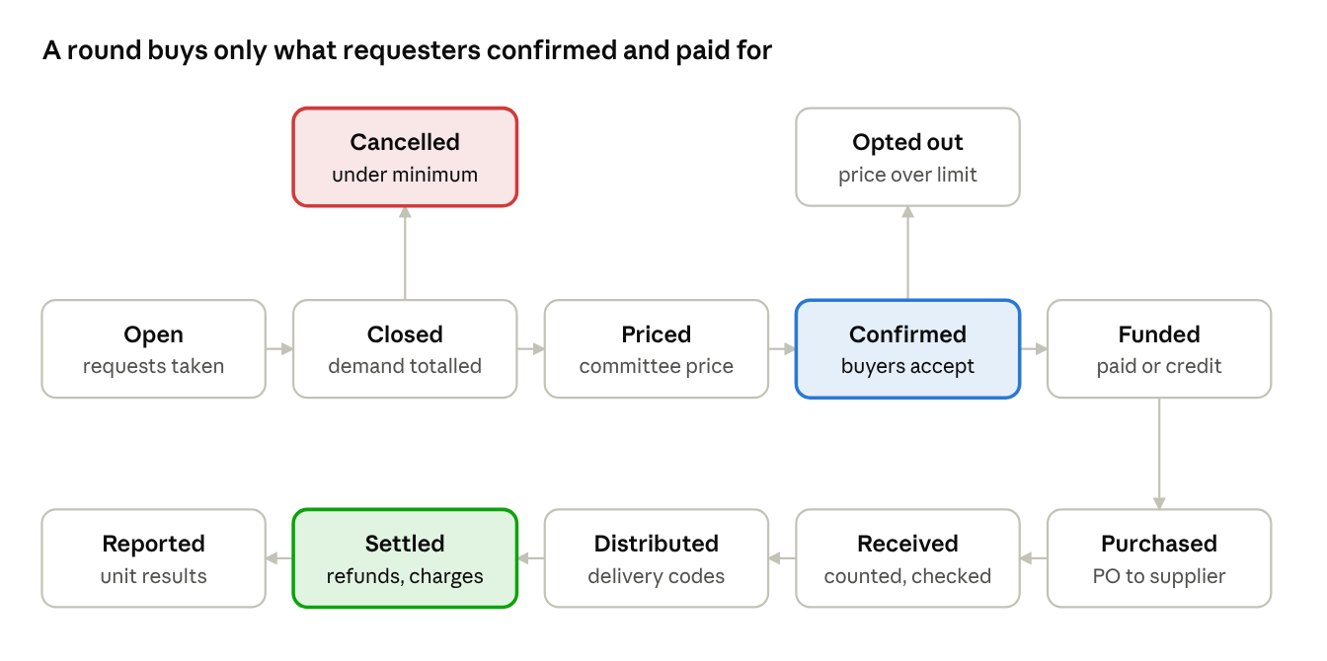
request round lifecycle · ten steps, two exits
The round, step by step.
- Open. The unit opens a round with an opening and closing date and the items on offer. Every member sees it. Allowed requesters submit a request: item, specification, quantity and their price tolerance. A price tolerance of "up to 5% above the indicative price" means they accept automatically within it.
- Closed. At the closing date, the system adds up demand by item and specification. If the minimum subscription is not met, the unit applies its rule. The choices are:
  - cancel and refund;
  - extend the closing date once;
  - let the unit take the unfilled part and resell it.
- Priced. The procurement officer collects quotes for the total demand. The committee chooses a supplier and sets each item's price, including the service fee. The price sheet and quotes are published to the round's requesters. The proposer cannot be the approver.
- Confirmed. Requesters within their tolerance are confirmed automatically. Others must accept within the confirmation window, or they drop out. Anyone can opt out before funding with no charge.
- Funded. Money is raised for exactly the confirmed demand, by one of four routes:
  - upfront payment;
  - savings debit with consent;
  - payroll credit for members and allowed staff;
  - a society advance within the ceiling.
Purchase starts only when the round is fully funded.
- Purchased. A purchase order goes to the chosen supplier. Payment is approved by two signatories from the unit account.
- Received. The receiving officer counts and inspects the goods against the order. Shortages, damage and substitutions are recorded.
- Distributed. Goods are packed per requester. A different person hands them over against the code sent to the requester or their named proxy.
- Settled. The system compares what each requester paid with what they received. It refunds overpayments and charges shortfalls within the variance rule. Undelivered items are refunded. A requester's credit plan is adjusted to what was actually delivered.
- Reported. The round's results are published to members:
  - demand, quantities bought and prices paid;
  - fees, variances and refunds;
  - any surplus or loss.
When supply is short. The unit's allocation rule decides who gets what. The choices are:
- pro rata to confirmed quantities (the default);
- first confirmed, first served;
- members before non-member staff;
- a published lottery.
Every shortfall is refunded or removed from the credit plan.
Substitutions. Each request line carries the requester's choice: no substitute, a similar item at no more than the confirmed price, or ask me first.

7. Watanda: shared purchase of an animal
The tradition. In northern Nigeria, a Watanda group of a few people saves together, buys a cow and splits it, often for Sallah. Each member gets an equal share of flesh, bone, offal and skin. Groups usually run on WhatsApp and bank transfers. No Nigerian app was found that digitises Watanda, which makes this unit a real gap to fill (research, 11 October 2026).
How the Watanda unit is configured.
Setting | Choices
Animal | Cow, ram, goat or any other animal set up in the catalogue
Share method | Equal shares, the traditional way: the animal is split into N equal shares and each requester takes one or more. By quantity: requesters ask for kilograms, and the committee works out how many animals are needed
Number of shares | Set by the committee before the round, for example 10 or 20 per cow
Festival sacrifice mode | For Eid al-Adha: at most 7 shares per cow, and a ram or goat belongs to one person only. Slaughter falls within the festival days, and each owner's intention is recorded
Parts of the animal | Each part has its own policy: flesh, bone, offal, head, legs and skin. The policy is split equally, sold with the cash shared, or given to the butcher
Pricing | Budget first: the round raises a set amount and the committee buys the best animal it affords. Cost plus: the animal plus transport, inspection, slaughter, butchering and delivery, divided by the shares
Saving period | Optional. Requesters pay in instalments over months before the festival, held in the unit account
Unfilled shares | Cancel, extend once, or the unit takes and resells them
Slaughter | A licensed abattoir only, with the veterinary inspection receipt attached
Collection window | Hours, not days, because most meat is sold fresh without cold storage
The Watanda round, step by step.
- Open. The round opens with the animal type, the number of shares, the indicative price per share and the slaughter date. Members, and staff where allowed, take shares or request kilograms.
- Close. The round must be fully subscribed. In quantity mode, the system converts the kilograms requested into the number of animals needed, using the expected yield.
- Price. The procurement officer and a second committee member inspect and price animals at the market. The committee approves the purchase price and the cost sheet. Requesters confirm, or opt out.
- Fund and buy. Payment comes from the unit account with two signatures, and the seller's receipt is attached. The animal is recorded with photos, tag or description, and its estimated weight.
- Slaughter. At the licensed abattoir, the carcass weight is recorded and the inspection receipt attached.
- Share out. The butcher prepares the heaps. Each heap is weighed or counted and photographed, and the allocation follows the share method.
- Collect. Each requester or proxy collects against their code within the collection window.
- Settle. Actual costs are compared with what was collected. Each share gets a refund or a small top-up. In quantity mode, any difference between the meat requested and the meat delivered is settled per kilogram.
- Report. The round report shows the animal, its cost, every fee, the carcass weight, the heaps and the settlement.
Worked example. All figures are illustrative assumptions.
Item | Amount
Cow, about 350 kg live weight | ₦2,500,000
Transport to the abattoir | ₦50,000
Abattoir and veterinary inspection | ₦10,000
Slaughter and butchering | ₦40,000
Total cost | ₦2,600,000
Shares | 20
Price per share | ₦130,000
At a dressing yield of about 46%, the carcass weighs about 161 kg. About 65% of that is boneless meat, roughly 105 kg, or about 5.2 kg per share, plus bone and offal. That is about ₦24,800 per kilogram of boneless meat. Lagos retail beef sold about ₦7,500 to ₦9,500 per kilogram in May 2026 (secondary source). Watanda's value is trust, freshness and festival availability, not always price. So the price screen must always show the cost per kilogram next to the market price, and requesters decide with that in front of them.

8. Essential commodities and asset requests
Essential commodities. Members, and staff where allowed, can request any goods in the unit's catalogue in any quantity within the limits. They can also request an "other item" described in their own words. The amount they pay is set by the committee after sourcing, never at request.
How it runs.
- Requests. The unit is always open. Requests are grouped into rounds at each cut-off date, for example every Friday, or monthly before payday.
- Other items. The committee accepts, maps or rejects each one, with a reason.
- Pricing. The committee prices each item and specification from quotes. Requesters confirm per line, or are confirmed automatically within their tolerance.
- Fulfilment. Goods are taken from stock where Inventory holds them, or bought for the round.
- Hand-over and settlement. Delivery is against codes. Settlement refunds anything short, substituted for less, or not delivered.
Food safety and NAFDAC.
- Buy only NAFDAC-registered packaged foods, and hand them over unopened.
- Never re-bag goods into branded sacks. NAFDAC treats that as counterfeiting.
- Repacking under the society's own label needs its own NAFDAC registration.
- Raw meat and fresh produce follow state veterinary and market rules.
Asset requests. Members request durable assets, such as an inverter, fridge, laptop or motorcycle, through an asset unit.
- Rules. The rules from version 2.2 carry over:
  - the committee prices from quotes, and the board approves above its threshold;
  - a guarantor is needed above the threshold;
  - payroll credit for members and allowed staff, with markup earned month by month and early payoff at any time;
  - delivery is against a code, with a serial number and photos;
  - the society keeps title until the last instalment.
- Asset records. Assets bought for members sit in the asset register as the society's until fully paid. They then pass to the member, and the register records the transfer.

9. Who can take part, and how they pay
Version 3.1 rewrites this section. Non-member staff can now buy on payroll credit, and anyone on credit can pay early, in part or in full, at any time.
Participants and payment modes.
 | Members | Non-member staff, where the unit allows them
View the unit | Yes | Yes, once registered on the platform
Make requests | Yes, within limits | Yes, within limits
Pay instantly by transfer, card, or cash at a collection point | Yes | Yes
Pay on delivery | Where the unit allows it | Where the unit allows it
Savings debit with consent | Yes | No savings to debit
Payroll credit | Yes, within credit headroom | Yes, within deduction capacity, where the unit has staff credit switched on
Pay off early, in part or in full | Yes, at any time | Yes, at any time
Priority when supply is short | Optional rule: members first | After members, if that rule is on

9.1 Payroll credit for non-member staff
Why it works. Non-member staff are on the same employer payroll as members. Their instalments are recovered by payroll deduction with their written consent, just like members' instalments.
Conditions.
- The unit's settings. "Staff credit" is switched on in the unit's settings, and the board approves it.
- The employer agreement. The employer's deduction agreement covers non-member staff, not only members.
- Consent. The staff member signs a deduction consent in the app, confirmed with an OTP, for each plan.
- The credit limit. Non-members have no savings, so their limit comes from their deduction capacity: the share of net pay the agreement allows, minus their existing deductions. The unit also sets a ceiling per person.
- A guarantor. The unit may require a member guarantor above a set amount.
- Leaving employment. If a staff member leaves, the balance becomes due. It is recovered from the final pay as the consent allows, and any guarantor is alerted. There are no savings to offset it against, which is why the guarantor and final-pay consent matter.
Records. Staff credit is kept in separate accounts from member credit. Arrears are aged per person and reported separately to the board.
Legal note. Section 30 of the Co-operative Societies Act bars lending to non-members, except to other cooperatives. To stay on the right side of it, staff credit follows three rules:
- No cash. Staff credit is always a sale of goods with deferred payment, never cash lent. No money is ever paid to a staff member.
- Bye-laws. The society's bye-laws must allow sales to non-member staff on deferred payment.
- Counsel. Counsel confirms the structure before the first staff credit plan. This is listed as an open issue.

9.2 Choosing and changing how to pay
- At confirmation. Each requester chooses to pay now in full, or to pay on credit over a tenor the unit allows.
- Pay off in full at any time. A requester on credit can pay the whole remaining balance whenever they like, and the plan closes. Markup is only earned month by month, so markup for the months not yet reached is never charged. A unit may set an early repayment fee, but the default is none.
- Part payments. A requester can pay part of the balance at any time. They then choose fewer remaining months at the same instalment, or the same months with a smaller instalment. The markup is worked out again on the reduced balance.
- From pay-now to credit. A requester who chose to pay now can switch to credit before the round is funded, if they are eligible.
- When the deduction schedule is already sent. If this month's schedule has gone to the employer, the change takes effect from next month. If the employer still deducts, the extra amount is found when the remittance is matched. The requester chooses whether it is refunded or applied to another plan.
- How to pay early. By transfer to the unit's account with the plan reference, by card, by savings debit for members, or in cash at a collection point against a receipt. The payment is confirmed in the same way as any other: by a connector, or by a second person in manual mode.
- What the requester sees. Their statement shows the balance, the markup earned so far, the markup saved by paying early, and the next deduction.
Worked example. These figures continue the commodity example from version 2.2.
- The plan. A requester takes goods with a cash price of ₦154,000, over 3 months at 5% flat. The markup is ₦7,700, and the instalment is ₦53,900.
- After month 1. Month 1's markup of ₦2,567 has been earned, and ₦53,900 has been deducted. The balance is ₦102,667.
- Paying off. The requester pays ₦102,667 at the start of month 2, and the plan closes. Staying on the plan would have cost two more instalments, ₦107,800, so paying early saves ₦5,133 of unearned markup.

9.3 Society advances, consumption and refunds
Society advances.
- When used. A member service unit can take an advance from the society within its approved ceiling, to buy before credit is repaid.
- Approval. Advances above the board's limit need a general meeting resolution.
- Repayment. Advances are repaid from collections, including early payments, before any surplus is counted. An overdue advance raises an alert.
Consumption, never investment. Units sell goods for use. They never promise investment returns.
Refunds. Refunds go back by the method used to pay, within a set time (default 3 business days):
- a cancelled round is refunded in full;
- an opt-out before funding is refunded in full;
- settlement differences are refunded or charged per requester;
- credit plans are reduced instead of refunded;
- payroll over-deductions are refunded or applied, as the requester chooses.

10. Venture units: from proposal to exit
A venture unit is a business the society invests in to earn profit, such as buying a car and running it, a shop, a filling station or an estate. A venture committee runs it from the first payout to the last profit return.
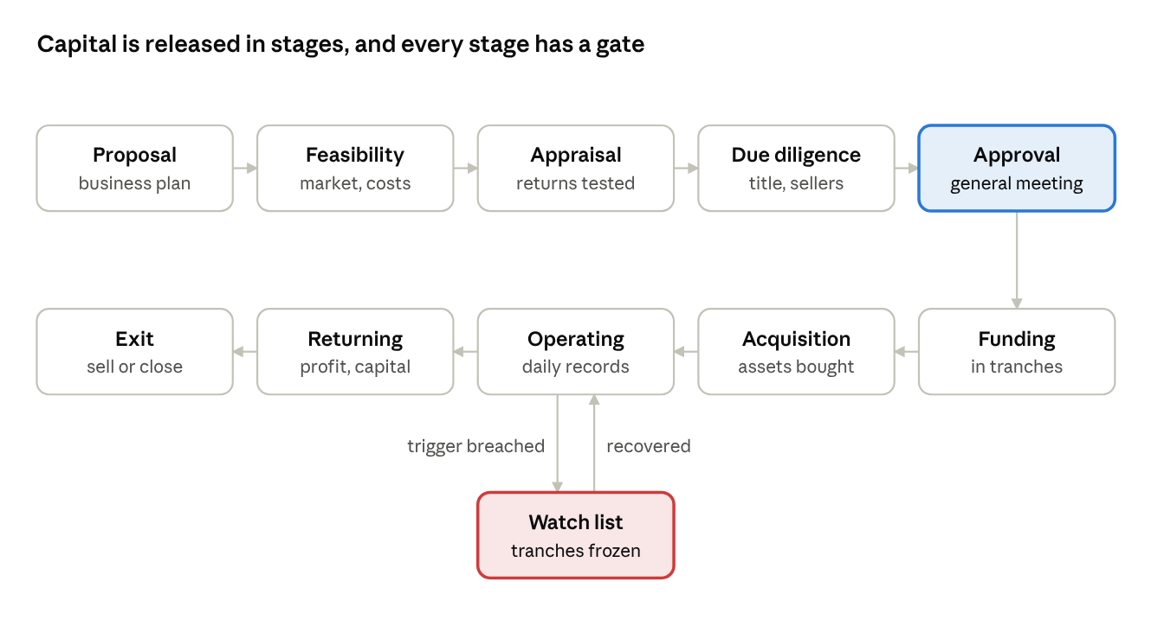
venture lifecycle · ten stages and a watch list
Each stage and its gate.
- Proposal. The sponsor, usually the board or a group of members, describes the venture, the capital needed, the team and the expected return.
- Feasibility. This covers the market, prices, costs, licences, location and competition. For transport it covers routes, apps and driver demand. For estates it covers land, demand and building costs.
- Appraisal. The system works out the payback period, the net present value at the society's hurdle rate, and the internal rate of return. It also tests the plan at worse prices and higher costs.
  - Hurdle rate. The hurdle rate is set by the board, for example 25% to 30% a year for transport in late 2026. The CBN policy rate was 23%.
  - Liquidity test. The society must still meet member withdrawals after the investment.
  - Lending comparison. The appraisal is compared with what the same money earns as member loans.
- Due diligence.
  - Assets. The seller's identity, title documents and inspection.
  - Property. Certificate of Occupancy, Governor's consent, survey charting, and litigation and community searches.
  - Licences. Whether the venture's licences can actually be obtained.
- Approval. The board recommends, and the general meeting approves the venture, its capital ceiling and its tranche plan. The vote and any declared interests are recorded.
- Funding. Capital is released in tranches against milestones, by two-signature payments from the main account to the venture's own account.
- Acquisition. Assets are bought through purchasing, paid from the venture account, and entered in the asset register with documents.
- Operating. Daily operations are recorded: collections, expenses, fuel, maintenance and sales.
- Returning. Profit and capital go back to the society on the agreed schedule.
- Exit. The venture is sold, wound down or its assets disposed of. The final return is computed, and the unit is closed.
Monitoring and the watch list.
- Targets. Each venture has targets from its plan.
- Amber. One month below a target puts the venture on amber, and the committee explains.
- Red. Two months below, a breach of a hard limit, or a failed liquidity test puts it on red. Red freezes any undrawn tranches, and the board must decide to fix, re-plan or exit.
- When to exit. When continuing is worth less than selling, or the society's liquidity is at risk.
Governance.
- The venture committee includes at least one member who is independent of the venture's operations.
- Conflicts. Interests are declared in a register members can see. Anyone with an interest steps out of the decision.
- Related parties. Assets are never bought from, sold to or leased to an insider without an independent valuation and board approval. Insiders never get hire-purchase deals on venture assets.

11. Venture types
Transport. For example, the society buys a car, bus or tricycle and runs it.
- Buying.
  - New or used vehicles through purchasing.
  - Registration, plates and permits in the society's name.
  - At least third-party insurance. The NAICOM minimum is about ₦15,000 for a car and ₦5,000 for a tricycle, and comprehensive cover runs at least about 5% of the vehicle's value.
  - A tracker on every vehicle.
- Driver models. The venture picks one per vehicle:
  - salaried driver;
  - fixed daily or weekly returns, often ₦15,000 to ₦30,000 a day (secondary sources);
  - hire purchase, where the driver pays over 2 to 4 years and owns the vehicle at the end.
Ride-hailing schemes have charged about 1.6 to 1.7 times the vehicle's price.
- Collections. Each driver pays into their own reserved account number, never in cash to the manager. Missed returns are aged per driver. Tracker data and fuel and odometer logs are checked against returns.
- Running costs. Fuel, maintenance and repairs are approved and paid from the venture account, against the asset's maintenance log.
- Targets.
  - revenue per vehicle per day;
  - days on the road;
  - maintenance cost per kilometre;
  - arrears per driver.
- 2026 lesson. Uber stopped operating in Nigeria in September 2026, and the fleet financier Moove announced its exit in October 2026 (secondary sources). A transport venture must not depend on one app's earnings, and its funding should be in naira.
- Worked appraisal. These figures are illustrative arithmetic, not a quote.
  - Daily returns. An ₦18m used car earning ₦20,000 a day in returns has a return of about 10% a year. That is below a 25% hurdle rate, so it would be rejected.
  - Hire purchase. At about 1.67 times the price over four years, the same car clears the hurdle. It still does if a defaulting driver's car is recovered and re-let.
Shops and filling stations.
- Modules used. Sales and till, inventory, cash handling and purchasing, exactly as in version 2.2.
- Filling stations add:
  - petroleum licences;
  - pump calibration (the regulator ordered every pump recalibrated on 22 September 2026);
  - a daily reconciliation of pump readings against tank dips and deliveries, within a tight tolerance, for example 0.5%.
Estates.
- Before buying land. Full title checks: Certificate of Occupancy, Governor's consent, survey charting, litigation search and community search. Land encroachment disputes affecting cooperative estates recur, including one in July 2026.
- Buyer deposits. Off-plan deposits are kept in a separate deposit account in the society's name. Lagos has no legal escrow for off-plan deposits, so the platform enforces its own ring-fence. Deposits are released to the contractor only against a quantity surveyor's certificate for work done, with 5% to 10% retention held back until completion.
- Accounting. Houses built for sale are stock until handover, when the sale is recognised, and buyer instalments are held as deposits until then. Houses kept to rent are investment property, earning rent.
- The main danger. Funding an estate with savings members can withdraw is the commonest cause of collapse. An estate venture needs long-term capital, and must pass the liquidity test before every tranche.
Any other venture. Equipment leasing, farms, water factories or event rentals use the same lifecycle, asset register, collections and returns. Their targets are set in the plan.

12. The asset register
Every durable asset bought by a unit is recorded in the asset register. That includes vehicles, equipment, buildings, land, and assets held for members until they are paid for.
Field | Example
Asset number, type and description | V-0007, car, Toyota Corolla 2015
Identifiers | Plate number, chassis number, serial number, land survey number
Owning unit and funding source | Transport venture, tranche 2
Location and custodian | Driver A. Musa, Kaduna depot
Cost and date in use | ₦18,000,000 on 1 November 2026
Depreciation | Straight line over 5 years, or by kilometres or hours used, with a residual value
Insurance | Policy, insurer and expiry date
Permits and licences | Vehicle licence, road worthiness and hackney permit, with expiry dates
Maintenance | Schedule and log, with every repair and its cost
Tracker | Device number and last position
Status | In use, under repair, on hire purchase to a named driver, held for a member, disposed
Documents | Purchase receipt, title, registration and inspection reports
Rules.
- Recording. An asset enters the register when it is received, with its documents. Nothing is paid for an asset without a register entry.
- Depreciation runs monthly into the owning unit's books.
- Expiry alerts. Insurance, permits and maintenance due dates alert the venture manager 30 days ahead. They alert the board if they lapse.
- Impairment. A damaged asset, or one earning far below plan, is tested for impairment and written down if needed.
- Disposal needs committee approval, and board approval above a set value. A related-party buyer needs an independent valuation. The sale price, the book value and the gain or loss are recorded.
- Hire purchase. An asset on hire purchase stays in the register as the society's until the last instalment. The balance owed is tracked as a receivable from the driver.
- Member assets. Assets bought for members under asset requests also stay as the society's until fully paid. Ownership then transfers to the member.

13. Shared operating modules
These modules serve every unit. Their rules carry over from version 2.2 unless stated.
Inventory.
- What it is. A separate entity holding stock for any unit that stores goods. It keeps four levels: on hand, reserved, available and in transit.
- How stock moves. Stock comes in on goods-received notes and leaves on sales, deliveries with codes, transfers and approved write-offs.
- Counts. A monthly blind count and weekly spot counts.
- New in this version. A round that buys for immediate distribution, such as Watanda meat, can skip storage. Goods go straight from receipt to distribution, but every delivery still needs a code.
Purchasing.
- Process. Approved suppliers, three quotes above the threshold, and a three-way match with quantity exact and price within 2%.
- Safeguards. A cooling-off period on supplier bank changes, and anti-splitting.
- Withholding tax is deducted at the correct rate.
- New in this version. For rounds, the procurement officer attaches the quotes to the round. The committee's chosen quote becomes the round price sheet.
Expenses and petty cash. Approved expenses are paid only from the bank. Petty cash runs on a fixed float, topped up against receipts, and never from a till.
Sales and till. Used by shop and filling-station ventures, as in version 2.2:
- five payment channels;
- bank confirmation for transfers;
- numbered receipts;
- refunds approved by the manager.
Cash handling. Fixed float, safe drops, a blind two-person count, a ₦1,000 tolerance, banking by the next business day, and nothing paid from the till.
Payments.
- Approval. Every payment from any unit account needs two of three signatories.
- Execution. It goes through a connector, or through the bank's own channel in manual mode.
Member credit and payroll check-off. Credit is open to members and, where a unit allows it, non-member staff on the same payroll. It covers headroom or deduction-capacity checks, instalment plans on the deduction schedule, line-by-line remittance matching, and arrears ageing.
Reconciliation.
- Starting point. It starts from the bank statement, and every line ends cleared or as a break.
- Two tracks. Automatic matching, or a maker and a checker.
- No write-offs. Bank differences are never written off.
Periodic proof and reporting.
- Proofs. Separate bank and cash proofs, on each unit's configured cadence.
- Packs. A monthly pack for each unit, and a consolidated society pack.

14. The ledger for units, rounds and ventures
The ledger is the platform-built module from version 2.2. Its rules are unchanged:
- one book per society in kobo, plus a quantity book for stock;
- journals that can never be edited and post all-or-nothing;
- overdraft guards enforced by the database;
- holds for payouts and reservations;
- a fingerprint chain and a nightly self-check.
This section adds how units, rounds and ventures are recorded.
Every account and journal is tagged with its business unit. Round entries also carry the round number, and venture entries the asset number where one applies. Each unit, each round and each asset can be reported on its own without separate books.
Member service units.
Event | Debit | Credit
Upfront payment received for a round | Unit bank | Requester prepayments (one account per requester per round)
Society advance to the unit | Society: advance to unit. Unit: unit bank | Society: main bank. Unit: due to society
Round purchase paid | Round cost pool, or stock if it goes into inventory | Unit bank (two signatures)
Goods delivered to a prepaid requester | Requester prepayments, at the confirmed price | Round sales, and service fee income
Cost of goods delivered | Cost of round sales | Round cost pool
Goods delivered on payroll credit | Member credit owed | Round sales. The markup is then earned monthly
Settlement refund | Requester prepayments | Unit bank
Settlement top-up charged | Requester receivable | Round sales
Advance repaid | Unit: due to society. Society: main bank | Unit: unit bank. Society: advance to unit
Sales to non-member staff go to separate accounts: non-member prepayments, non-member sales and staff credit owed.
Paying early, and changing how to pay.
Event | Debit | Credit
Early payment in full | Unit bank | Member or staff credit owed, for the balance to date. Markup not yet earned was never recorded, so nothing needs reversing
Early repayment fee, if the unit sets one | Unit bank | Fee income
Part payment | Unit bank | Member or staff credit owed
Payroll over-deduction after payoff | Bank, when the remittance is matched | Requester overpayment, a liability
Over-deduction refunded | Requester overpayment | Unit bank
Over-deduction applied to another plan | Requester overpayment | Credit owed on that plan
A round can only be closed when:
- every requester's prepayment balance is zero;
- the round cost pool is zero;
- any difference is recorded as the round's surplus or loss with an explanation.
Venture units.
Event | Debit | Credit
Capital tranche | Society: investment in venture. Venture: venture bank | Society: main bank. Venture: capital from society
Asset bought | Asset at cost, such as vehicles or property | Venture bank
Monthly depreciation | Depreciation expense | Accumulated depreciation
Driver's daily return received | Venture bank | Transport income, or the driver's hire-purchase balance and interest income
Vehicle put on hire purchase | Hire-purchase receivable from the driver | Vehicle at book value, and income on the financing over the term
Estate buyer deposit | Estate deposit account | Buyer deposits held (a liability until handover)
Estate unit handed over | Buyer deposits held | Sales. The cost of the unit moves from stock to cost of sales
Expense paid | Expense by type | Venture bank
Profit returned | Profit returned to society | Venture bank
Capital returned | Capital from society | Venture bank
Rules.
- No dividend is ever paid out of capital.
- An allowance for expected losses is held against hire-purchase and member credit balances, by age.
- An asset that is damaged or earning far below plan is tested for impairment.

15. Profit, returns and year-end
Member service units.
- The aim is cost recovery plus any small service fee the unit is configured with, not profit.
- Each round reports its surplus or loss.
- Monthly sweep. Each month, any society advance is repaid first. Unit surplus above its working float then goes to the society's main account.
- A round loss is covered from the unit's own past surplus. Beyond that, the board decides whether the society absorbs it. A loss is never charged back to requesters after settlement, except through the variance rule they accepted.
- Patronage refunds. The general meeting can choose to share surplus as patronage refunds, in proportion to each member's purchases across all service units.
Venture units.
- The monthly venture pack shows:
  - income and costs, with depreciation and maintenance;
  - net profit;
  - return on capital against the plan and the hurdle rate;
  - collections and arrears;
  - targets with their amber or red status.
- Cash returns. The venture keeps its approved working capital. Each month it returns cash above that level. The amount up to profit earned and not yet returned counts as profit returned. Only the rest counts as capital returned.
- New tranches need a passed liquidity test and no red status.
- Exit. At exit, the final proceeds return to the society, and the venture's lifetime return is reported to members.
Year-end, for the whole society.
- Tax. Tax on trading profit is computed first. Venture and trading profits are taxable under the Nigeria Tax Act 2025 unless small-company relief applies.
- Reserve fund. At least 25% of net profit goes to the reserve fund.
- Education fund. Up to 10% of the remainder may go to an education fund, with the Director's approval.
- The general meeting decides the rest: dividends on shares, patronage refunds and retained surplus.
- Members' report. The annual report shows each unit's and each venture's result separately, so members can see which activities earn and which cost them.

16. Governance, alerts, freeze and the optional integrations hub
Alerts. Alerts carry over from version 2.2 for tills, stock, banking, suppliers, related parties, manual journals and critical breaks. New alerts:
- Short of minimum. A round closes below its minimum subscription.
- Price jump. A round price is more than the price change limit above the indicative price.
- Large variance. A round's quantity variance is larger than its tolerance.
- Slow recovery. A society advance to a unit is not recovered by its due date.
- Venture shortfall. A venture misses its plan's collections or profit for two months in a row.
- Asset paperwork. An asset's insurance, permit or maintenance is overdue.
Emergency freeze. The supervisory committee can freeze any single unit.
- What it blocks. All outgoing payments from that unit stop. Incoming money is still recorded.
- Board decision. The board must meet within 48 hours, and the freeze stays until a board resolution lifts it.
Audit trail. Every action is recorded for at least five years with the user, the time and the before-and-after values. That includes settings changes, prices, allocations and approvals.
Integrations hub, optional. Every unit works fully in manual mode. Connectors for bank and BaaS payouts, collections accounts, statements, card terminals, payroll and Remita, identity checks and SMS can be switched on per society and per capability. A connector produces the same records as the manual task it replaces, and never changes who approves what.

17. Acceptance tests
Tests TC-01 to TC-38 from version 2.2 still apply to the shared modules. These tests cover what version 3.0 adds.
Test | What is tested | How | Expected result
TU-01 | Unit set-up | Create a Watanda unit without a committee or account | It cannot leave Draft
TU-02 | Visibility | A member opens the units list | Every active unit shows, with its rules and results
TU-03 | Requester groups | A non-member staff member requests in a members-only unit | Refused
TU-04 | Credit for non-members | Non-member staff choose payroll credit in a unit that allows staff | Offered within the staff member's deduction capacity, with signed consent. Not offered if the unit has staff credit switched off
TU-05 | Catalogue | Request rice with a brand and size not in the specification list | Refused, unless "other item" is allowed, when it goes to the committee
TU-06 | Minimum subscription | A Watanda round of 20 shares closes with 17 taken | The unit's rule applies: cancel and refund, extend once, or the unit takes 3
TU-07 | Festival mode | Set 10 shares on a cow, or 2 owners on a ram, in Eid mode | Refused. At most 7 per cow, one owner per ram
TU-08 | Price setting | The procurement officer approves their own proposed price | Refused. Another committee member must approve
TU-09 | Price tolerance | Final price 4% above indicative, with tolerances of 5% and 3% | The 5% requester is confirmed automatically. The 3% requester must accept or drop out
TU-10 | Funding before purchase | Raise a purchase order before the round is fully funded | Refused
TU-11 | Allocation | 100 bags confirmed, 80 delivered, pro rata rule | Each requester gets 80% of their quantity. The rest is refunded or removed from credit plans
TU-12 | Settlement | Close a round with a requester's prepayment balance not zero | Refused until it is settled
TU-13 | Cost per kilogram | Open a Watanda price screen | Shows cost per kilogram next to the market price
TU-14 | Abattoir evidence | Record slaughter without a licensed abattoir and inspection receipt | Refused
TU-15 | Society advance | An advance above the board's limit without a general meeting resolution | Refused
TU-16 | Advance repayment | Sweep unit surplus while an advance is unpaid | The advance is repaid first
TV-01 | Venture approval | Release a tranche with no general meeting approval | Refused
TV-02 | Liquidity test | Release a tranche when the liquidity test fails | Refused, and the board is alerted
TV-03 | Watch list | A venture misses its collections target two months running | It goes red, and undrawn tranches are frozen
TV-04 | Asset before payment | Pay for a vehicle with no asset register entry | Refused
TV-05 | Driver collections | A driver's return recorded as cash paid to the manager | Not allowed. Returns go only to the driver's reserved account
TV-06 | Related-party sale | Sell a venture asset to a committee member without an independent valuation | Refused
TV-07 | Estate deposits | Release deposit money to a contractor without a quantity surveyor's certificate | Refused, with retention held back
TV-08 | Profit or capital | Return ₦1m after two months of ₦300,000 profit with nothing returned | ₦600,000 profit returned and ₦400,000 capital returned
TV-09 | Expiry alerts | Vehicle insurance expires in 30 days | Alert to the venture manager, then the board if it lapses
TV-10 | Pump reconciliation | Pump readings and tank dips differ by more than 0.5% | Break opened and the manager alerted
Added in version 3.1.
Test | What is tested | How | Expected result
TU-17 | Early payoff | Pay ₦102,667 after month 1 of a 3-month, ₦154,000 plan | Plan closed, ₦5,133 of markup never charged, next deduction removed
TU-18 | Part payment | Pay ₦50,000 part-way through a plan | The requester chooses fewer months or smaller instalments, and the schedule updates
TU-19 | Schedule already sent | Pay off after this month's schedule has gone, and the employer still deducts | The over-deduction is found at matching, and refunded or applied as the requester chooses
TU-20 | Staff credit switched off | Non-member staff request credit in a unit with staff credit off | Only pay-now and on-delivery are offered
TU-21 | Staff credit limit | Staff request credit above their deduction capacity | Refused, with their capacity shown
TU-22 | Staff leaving | A staff member with a balance leaves employment | The balance becomes due, recovery from final pay is raised, and the guarantor is alerted
TU-23 | Pay-now to credit | Switch from pay-now to credit after the round is funded | Refused. Allowed only before funding

18. Open issues and sign-off
# | Issue | Owner | Needed by
1 | Confirm that each society's bye-laws allow cash sales to non-member staff (s.32 of the Act) | Counsel | Before any unit admits staff
2 | Confirm the Hire Purchase Act position at today's vehicle prices, and registration of hire-purchase vehicles at the collateral registry | Counsel | Before the first transport venture
3 | Abattoir fees and licensed abattoirs in each pilot state | Unit committees | Before the first Watanda round
4 | The society's hurdle rate and liquidity test, set by the board | Board and treasurer | Before the first venture appraisal
5 | The signed tax Act's small-company limit, ₦50m or ₦100m, and whether member trading is taxable | Tax adviser | Before design freeze
6 | Whether repacking under a society label is wanted, which needs NAFDAC registration | Board | Before any repacking
7 | Carry-over issues from version 2.2: ledger database, code freeze, load test, independent review, Labour Act deduction cap, POS providers | As in version 2.2 | As in version 2.2
Added in version 3.1.
- Staff credit and the law. Counsel to confirm that staff credit, structured as goods sold on deferred payment with payroll deduction, is consistent with section 30 of the Act. Each society's bye-laws must allow it. This is needed before the first staff credit plan.
- Employer agreements. Confirm that each employer's deduction agreement covers non-member staff, and agree how final-pay recovery works when staff leave. This is needed before staff credit goes live with that employer.
Any change to these rules needs the written approval of the board and the supervisory committee.
Name and designation | Role | Signature | Date
 | President or board chair
 | Treasurer
 | Supervisory committee chair
 | Lead architect

